Cimarron Elementary-Middle School News
November 2019 Edition
SHOUT OUTS!!!!
*Shout out to our students who have been “Rising Up” during the first few months of school.
*Shout out to Philmont staff for hosting field trips for our students to the National Scouting Museum, the Villa Philmonte, Rayado, and more!
*Shout out to our Turner Youth Group (and all who helped) to build an outdoor classroom pergola at CHS.
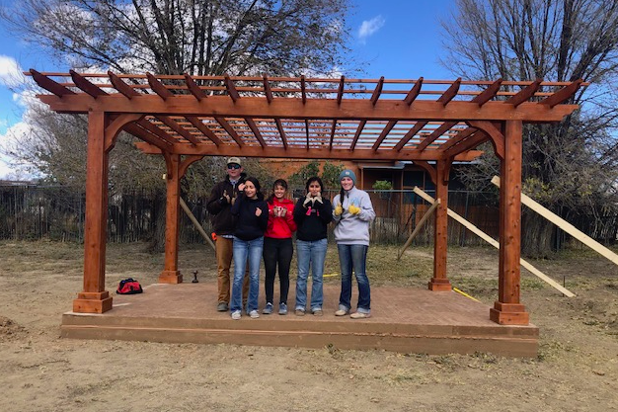

VETERANS’ DAY PROGRAM
Friday November 8th is the CHS Veterans Day Program at the Cimarron High School gym, starting at 2:00pm

K-4 NEWS
2nd grade finished their science unit on the human body. They learned about the systems of the body and created their own life size paper body with organs, muscles, and bones. They have also finished their math chapter on telling time.

K-4 went to Philmont Scout Ranch where they visited the National Scouting Museum, the Villa, and Rayado. They got to hear the story of Lobo, the legendary wolf, and how a blacksmith makes objects out of metal. 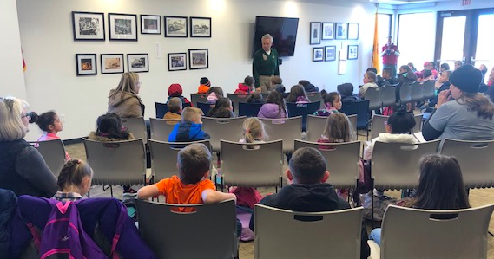 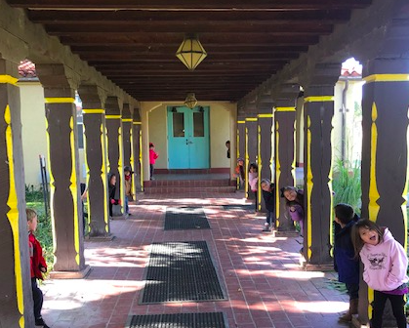

K-2 went on a field trip to Los Golondrinas in Santa Fe. We saw weavers, bread being made in an horno, and many people in period costume who explained what it was like to live in the territory of New Mexico.

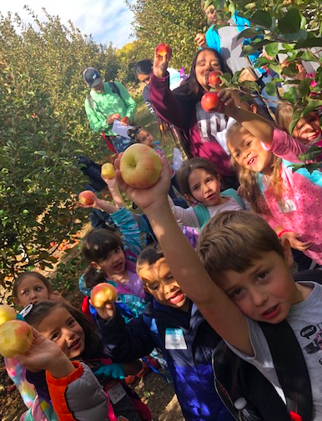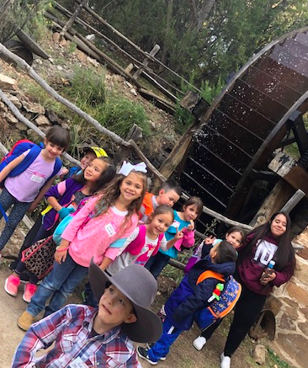
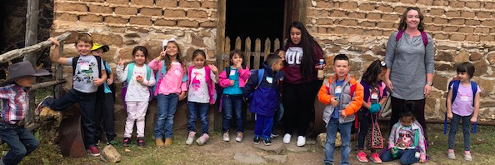

CEMS Band News
The CEMS band program had a very successful Band-o-Rama night on October 16th. I was very proud of how well all students performed, especially since their family members were sitting right next to them!
I want to remind parents that at-home practice is required at the middle school level. Please help make sure their instrument gets home and out of its case. I’ve found that once the instrument is out of its case, students can’t resist playing and the practice just happens!
The next important event is the Christmas Program on Wednesday December 18th at 6 pm in the CEMS PAC. Middle school students need to wear a white dress shirt and black dress pants or a skirt for that performance. Please begin shopping for concert clothing now. Seventh and eighth graders should check if their clothes still fit--most of them have grown a lot since last year!
Please find the “Cimarron Bands” page on Facebook and check out the new band website: https://sites.google.com/cimarronschools.org/cimarronbands/home.
Keep an eye out for the November and December deliveries of greenery. The November delivery will come in the week of November 12th.

FROM THE SCHOOL NURSE:
School Kids Influenza Immunization Project (SKIIP) Flu Vaccine Clinic
Date: Wednesday November 13th, 2019 Time: 10:00 am
Consent forms and information have been sent home with your child for the upcoming flu clinic. If you are interested in your child receiving the flu vaccine at school, please return the consent form ASAP. If you have any questions, please call the school nurse, Tiffany Arnold, RN
Cimarron Elementary Middle School (575)376-2512 ext. 204
Cimarron High School (575)376-2241 ext. 320
.
HALOS
HALOS stands for Helping and Leading our Schools. It is a parent/community/teacher organization that focuses on supporting students and the school. HALOS sponsors or helps with many great family events, such as the Fall Carnival, Family Math/Literacy Nights, Movie Nights, goodie bags for students during state testing, teacher appreciation events, etc. The carnival was a great success. Halos members and CEMS staff once again hosted a wonderful family event. In November, on the 22nd, they will host a Fall Dance for CEMS students and families.
Check out the HALOS facebook page: https://www.facebook.com/CImarronHALOS. There is also a “HALOS” tab on the district website. The next HALOS meeting is November 19 at 5:30 pm at CEMS cafeteria. We hope that you will join us!

CYAC
The CYAC (Cimarron Youth Athletics Committee) is a committee of parents and community members looking to support our young athletes (below middle school). This includes Pee Wee Basketball and Little League Baseball/T-ball. If you would like to join the CYAC, or just want to come to a meeting to see what it’s about, meetings are held at 5:00 on the first Sunday of each month at the CEMS cafeteria. Our next meeting will be Sunday, November 3.

BOX TOPS
We collect Box tops at Cimarron Elementary/Middle School. The box tops collected are sent in and submitted for items for our school. Please send/bring them in and place them in the big yellow box in the middle school hall.

ATTENDANCE
Please remember that we do have an attendance policy at CEMS. Your child's attendance is critical to their learning...if they aren't there to receive their instruction, then it makes it much harder to learn the concepts and complete the assignments. See the chart below to see the impact of missing school, even just one day every couple of weeks. Please make sure your child is at school ON TIME so that he/she can be successful in his/her classes.

Cimarron Middle School Athletics
CHS ATHLETICS
We want to congratulate our middle school and JV cross country and volleyball teams for great seasons! We also want to wish our Varsity XC and Volleyball teams the best of luck as they compete in district and hopefully state competitions! We are also excited about the start of basketball season and wish all basketball teams good luck for their upcoming seasons!

CROSS COUNTRY 2019
DATE | DAY | TIME | OPPONENT | LOCATION | DEPARTURE TIMES* | TEAMS
NOV 1 | FRIDAY | TBD | DISTRICT MEET | ATC in Santa Fe | TBA | V
9 NOV | SATURDAY | TBD | STATE XC MEET | TBA | TBA | V

VOLLEYBALL 2019
DATE | DAY | TIME | OPPONENT | LOCATION | DEPART* | TEAMS
Nov 3 | Sunday | 1:00 | District Meeting (SHS)
Nov 4-9 |  |  | District Volleyball Tournament | TBD
Nov 14-16 |  |  | State Volleyball Tournament | TBD

Basketball Schedule 2019-2020
DATE | DAY | TIME | OPPONENT | LOCATION | TEAMS
Nov 13 | Wednesday | 4:00 | Mora | Mora | EN & CIM Girls
Nov 14 | Thursday | 4:00 | Taos | Eagle Nest | EN G
Nov 20 | Wednesday | 4:00 | Taos | Taos | Cim G
Nov 30 | Saturday | 2:00 | Alumni Basketball | Cimarron | JV B/JV G VG and VB
Dec 2* | Monday | 4:00 | WLV Valley | Cimarron | Cim JHG
Dec 2 | Monday | 4:00 | Taos | Taos | EN G
DEC 2 | Monday | 4:00 | Penasco | Cimarron | Varsity G and Varsity Boys
DEC 4* | Wednesday | 4:00 | CLAYTON | Clayton | JH EN /JH CIM B&G
Dec 5 | Thursday | 4:00 | taos | Cimarron | Cim G
Dec 7* | Saturday |  | CLAYTON TOURNEY |  | JH- EN /CIM B&G
DEC 9 | Monday | 4:00 | Penasco | Cimarron | Girls JV and Boys JV
Dec 9-13 | Tues-Sat | TBD | Cowbell Tournament | Springer/Raton | GV/BV
Dec 10* | Tuesday | 4:00 | WLV valley | WLV Valley | EN JH G
Dec 17* | Tuesday | 4:00 | WLV Valley | WLV Valley | JH Cim G
Dec 20* | Friday | 4:00 | WLV Valley | Eagle Nest | EN JH G
Dec 21 | Saturday | 1:00 | Escalante | Cimarron | BJV/GJV/GV/BV
Dec 28 | Saturday | 2:00 | Coronado | Cimarron | BJV/GJV/GV/BV
Jan 6 | Monday | 4:00 | Clayton | Clayton | JV G/B B&G V
Jan 8 | Wednesday | 4:00 | Mora | Cimarron | EN & Cim Boys
Jan 9-Jan 11 | Thu-Sat | TBD | Cliff Tournament | Cliff | Girls Varsity
JAN 10-11 | Fri-Sat | TBD | Boys JV Tournament | Cimarron | Cimarron, Mora, Maxwell, Mesa Vista
Jan 13* | Monday |  | Taos | Taos | EN Boys
Jan 14* | Tuesday | 4:00 | Clayton | Cimarron | EN& CIM / B&G
Jan 17* | Friday | 4:00 | WLV Valley | Cimarron | Cim JH boys
Jan 16 | Thursday | 4:00 | Questa | Cimarron | B & G JV/V
JAN 18 | Saturday | 4:00 | Penasco | Penasco | B & G JV/B&G V
Jan 21 | Tuesday | 4:00 | Clayton | Cimarron | B&G JV/ B&GV
Jan 22* | Tuesday | 4:00 | WLV Valley | WLV Valley | EN JH boys
JAN 23 | Thursday | 5:00 | Wagon Mound | Cimarron | B &G V
Jan 24 | Friday | 4:00 | Taos | Taos | Cim Boys
24-25 JAN | Fri-Sat. | 8:00- 3:00 | Band Boot Camp | CHS
*JAN 25 | Saturday | 2:00 | Springer | Cimarron | EN JH G/B JVB VB (4 Games)
*Jan 27 | Monday | 3:00 | Des Moines | Des Moines | EN G/EN B VG/VB
Jan 27* | Monday | 4:00 | Taos | Cimarron | Cim Boys
Jan 29* | Wednesday | 4:00 | Taos | Eagle Nest | En Boys
Jan 31 | Friday | 3:00 | Maxwell | Cimarron | EN JH G/JH B/VG/VB
Jan31-Feb 1-2 | Fri -Sun | 1:00 | NMLC | Albq | Mid and HS
Feb 4 | tuesday | 4:00 | WLV valley | WLV Valley | JH Cim boys
Feb 6 | thurs |  | Roy/mosquero | Cimarron | Cim JH B&G - VG/VB
*FEB 8 | Saturday | 2:00 | Melrose | Melrose | B JV and G/B V
Feb 11 | Tuesday | 4:00 | WLV valley | Eagle Nest | EN Jh boys
*FEB 14 | Friday | 2:00 | Springer | Springer | CIM JH G/B JV B / V G/B
*FEB 15 | Saturday | 2:00 | Des Moines | Cimarron- Homecoming | CIm JH B/G VG and VB
*FEB 20 | Thursday | 5:00 | Roy/Mosquero | Mosquero/Roy | En B&G GV/BV
*Feb 21 | Friday | 4:00 | Wagon Mound | Wagon Mound | Cim JH B / BV
*FEB 22 | Saturday | 5:00 | Maxwell | Maxwell | GV/BV
Feb. 25-Mar. 2 | District Tournament | 6:00
March 8-9 | 1st Round State | 6:00
March 11-16 | State | TBS |  | Albuquerque
*games confirmed

Please see the calendar of events for November on the next page.

Check out the district website, www.cimarronschools.org, for athletic schedules, school and district information, the monthly newsletter, and much more!

If you, or your organization, have any announcements, events, etc. to be included in our monthly newsletters, please email it to jmartinez@cimarronschools.org by the 3rd Friday of the month, in order for it to go out on the next month's newsletter. If you would like a hard copy of our newsletter sent home with your child instead of receiving it via email or the website, please email Jody Martinez at the email address above.

